SOFTWARE ENGINEERING PROPOSAL

**NIDA KHALID**

**F2023065384**

**W-4**



**Submitted to:** MISS KINZA SARDAR

**SUBJECT:** Software Engineering

Library Management System

Table of Contents

1 Introduction 4

1.1 Purpose 4

1.2 Scope 5

2 Functional Requirements 6

2.1 FR01: Search Item (Books, Magazines and Journals) 6

2.2 FR02: Issue Item (Books, Magazines and Journals) 6

2.3 FR03: Re-Issue Item (Books, Magazines and Journals) 8

2.4 FR04: Return Item (Books, Magazines and Journals) 8

2.5 FR05: Delete Item (Books, Magazines and Journals) 9

2.6 FR06: Check Fine of the Item (Books, Magazines and Journals) 9

2.7 FR07: Remove Item Fine (Books, Magazines and Journals) 9

2.8 FR08: Update the Item Record (Books, Magazines and Journals) 10

2.9 FR09: Add new Item 10

2.10 FR10: View Account 10

2.11 FR10: Create Account (Students, Staff, Faculty) 11

3 Non-Functional Requirements 11

3.1 NFR01: Performance 11

3.2 NFR02: Security 11

3.3 NFR04: Documentation 12

3.4 NFR05: Disaster Recovery 12

3.5 NFR06: User Interface 12

4 Use-Cases 13

5 DATA FLOW DIAGRAM 25

25

Software Requirements Specification

# Introduction

Library Management System, a sophisticated and user-friendly solution designed to revolutionize the way libraries manage their collections and interact with users. In an era where efficiency and precision are important, this system addresses the diverse needs of both library users and administrators, providing a seamless experience for borrowing, returning, and maintaining an accurate inventory of items. The primary objective is to enhance overall efficiency by automating tasks, minimizing manual efforts, and ensuring a smooth flow of information. Catering to modern library requirements, the system accommodates a diverse range of items, including books, magazines, and journals, offering a feature-rich platform for users and administrators. Key features include comprehensive search functionality, efficient item issuance with user category-specific rules, streamlined return processes, dynamic re-issuance management, user-focused fine management, and simplified administrative tasks. The Library Management System is a holistic solution poised to elevate the library experience, embracing modern technology and incorporating a user-centric design to enhance accessibility, organization, and functionality in the digital age.

## Purpose

The purpose of the software requirements specification document is to specify all requirements for the Library Management System as well as those requirements that are suggested as improvements for the current system. The document explains the information that will be supplied as input to the system, its transformations and the required outputs. It also addresses the interactions between the desired system and its users. This document will also act as an aide for the upcoming object oriented analysis and design of the system. This will help the software designers in developing this system in accordance with the requirements given in this specification. This specification describes all functional and non-functional requirements, constraints, and other factors necessary to provide a complete and comprehensive description of the requirements necessary to design and develop the corresponding software systems

The software developers will use the document for the necessary understanding of the system when implementing and designing. The other concerned person is the client who would be able to understand the attributes and functions of the system being developed.

## Scope

The purpose of this software is to serve as a Library Management System for the University. It is designed to assist library staff in effectively managing their tasks, ultimately boosting productivity. The implementation of this system will digitally transform all library operations and records. This not only enhances productivity but also ensures clarity and transparency in the library's functioning, making it easier to track and manage various tasks efficiently.

Specifically, the software will meticulously track all item records, encompassing books, journals, and magazines within the library. It will record details such as publishers and the quantity of each item available. Additionally, the system will monitor the issuance of books, newspapers, magazines, and journals to students, teachers, or administrators. It will keep a record of how many items are issued to specific users, taking into account the predefined limits for each user category. Furthermore, the system will enforce specific time periods for item issuance, with corresponding fines for late returns. The late return fines will increase daily, depending on the duration of the delay.

A concise overview of the software's functionalities is provided below:

1. **Inventory Management:** This involves keeping track of all library items, including books, journals, and magazines. Details about publishers and the quantity of copies will be recorded.
2. **User Management:** The software will manage borrowing privileges for students, teachers, and administrators. It will track the issuance of items, including details about who borrowed them and for how long.
3. **Loan Policies and Fines:** The system will enforce borrowing limits and durations, as well as impose fines for late returns. The fines will escalate based on the duration of the delay.
4. **Automation and Digitalization:** Library functions and records will be digitized, automating routine tasks and enhancing overall efficiency and clarity in operations.
5. **Productivity Improvement:** The software aims to improve the productivity of library staff by automating repetitive tasks and providing a clearer overview of operations.
6. **Clarity and Transparency:** The system will offer a transparent view of how the library operates, facilitating the tracking and management of library-related tasks.
7. **Efficient Tracking:** An efficient tracking system will be implemented to monitor all activities related to the library, including borrowing, returning, and the assessment of fines.

# Functional Requirements

## FR01: Search Item (Books, Magazines and Journals)

|  |  |
| --- | --- |
| **Req. No.** | **Functional Requirements** |
| FR01-01 | The system shall enable the User to search the required item. Item has 3 different Categories (Books, Magazines, and Journals). User can search by providing the name, ISBN, Author Name or Library Code of the item. |
| FR01-02 | The search functionality should support both uppercase and lowercase to show similar results. |
| FR01-03 | The system shall show the details of the required (Name, ISBN, library Code, author name and the copies of this item available in the library) if the required item is available in the library. |
| FR01-04 | The system shall display a proper message in case of searched item is not found. |

## FR02: Issue Item (Books, Magazines and Journals)

|  |  |
| --- | --- |
| **Req. No.** | **Functional Requirements** |
| FR02-01 | System is bound to issue 3 books to students, 7 books to faculty and 5 books to staff. |
| FR02-02 | The maximum allowed days to keep an item for a student is 7 days, 21 days for teachers and 14 days for staff. |
| FR02-03 | The system shall display the item categories, prompting to make a selection. Following the user's input, the system should validate the choice, confirming the item's availability in the library records. If the chosen item is available, the system will proceed accordingly; otherwise, it will provide the user with appropriate guidance through a clear message. |
| FR02-04 | The system shall check if the number of issued item to a user does not exceed the maximum allowable limit. |
| FR02-05 | The system shall prompt the user to input the item name, followed by their user ID. The system shall set the return date according to the user maximum number of days allowed. |
| FR02-06 | The system is obligated to display a response to the user, indicating that the item has been successfully issued and specifying the duration of the issuance. |
| FR02-07 | The system shall guide user if they are unable to issue an item due to surpassing the maximum allowable number of issued items. |
| FR02-08 | The system shall update the record of relevant item and user in the database. |

## FR03: Re-Issue Item (Books, Magazines and Journals)

|  |  |
| --- | --- |
| **Req. No.** | **Functional Requirements** |
| FR03-01 | The system shall compare the current system date with the designated return date of the item. If the current date has not exceed the return date, the system should proceed to re-issue the item. |
| FR03-02 | The system shall update the return date of the relevant item. |
| FR03-03 | If the current system date surpasses the return date, the system is required to display an appropriate message, notifying the user that re-issuing of the item is not possible until the associated fine is cleared. |
| FR03-04 | The system must validate whether the user is attempting to re-issue an item that was not originally issued to them. In such cases, the system should provide a suitable message to the user. |

## FR04: Return Item (Books, Magazines and Journals)

|  |  |
| --- | --- |
| **Req. No.** | **Functional Requirements** |
| FR04-01 | The system must verify whether the user is attempting to return an item which is not originally issued to them. If such an attempt is detected, the system should provide a relevant message to the user. |
| FR04-02 | The system shall compare the current system date with the designated return date of the item. If the return date has not been reached, the system should initiate the returning process for the item, update the relevant records for both the item and the user, and display a message to the user confirming the successful return. |
| FR04-03 | If the current system date surpasses the return date, the system is required to display an appropriate message, notifying the user that returning is not possible until the associated fine is cleared. |

## FR05: Delete Item (Books, Magazines and Journals)

|  |  |
| --- | --- |
| **Req. No.** | **Functional Requirements** |
| FR05-01 | The system must check that the user (Admin) has login into the system to perform the tasks |
| FR05-02 | The system shall show item categories (Books, Magazines and Journals) to user, and ask the user to enter the relevant choice for further processing. |
| FR05-03 | After selecting the relevant category, system shall ask the user to enter the library code of the item to be deleted. If the library code existed, relevant data of the item will be deleted. |
| FR05-04 | The system shall show a proper message if the relevant item is not available in the library. |

## FR06: Check Fine of the Item (Books, Magazines and Journals)

|  |  |
| --- | --- |
| **Req. No.** | **Functional Requirements** |
| FR06-01 | After inputting the user's ID, the system shall display the user record, including a list of issued items, their respective issue dates, return dates, and associated fines. |
| FR06-02 | The system should display an appropriate message indicating that no fine is applicable to the user due to the absence of any issued items. |

## FR07: Remove Item Fine (Books, Magazines and Journals)

|  |  |
| --- | --- |
| FR07-01 | The system shall remove the item fine to the user upon providing their ID and the item's name. After providing a valid justification, the system will proceed to remove the fine. |
| FR07-02 | If the justification of the user is not acceptable then the system should display to the user that they have to pay their fine. |
| FR07-03 | The system shall display a proper message if the asked item is not issued to the user. |

## FR08: Update the Item Record (Books, Magazines and Journals)

|  |  |
| --- | --- |
| FR08-01 | The system must check that the user (Admin) has login into the system to perform the tasks |
| FR08-02 | The system shall show item categories (Books, Magazines and Journals) to user, and ask the user to enter the relevant choice for further processing. |
| FR08-03 | When User add the name of the item, the system shall check the availability of that document in the library. If it is available, the system shall allow the admin to change the relevant data of the item (Name, ISBN, Library Code, status of the item, copy Number, Author name). |
| FR08-04 | If the relevant item is not available in the record, the system shall show a proper message regarding this to user. |
| FR08-05 | The system must make changes in the relevant record of the item after completing the updating process. |

## FR09: Add new Item

|  |  |
| --- | --- |
| FR09-01 | The system must check that the user (Admin) has login into the system to perform the tasks, |
| FR09-02 | The system shall allow the user to add the relevant data of the item (Name, ISBN, Library Code, status of the item, copy Number, Author name). |
| FR09-03 | System shall update the record of the relevant item in the database. |

## FR10: View Account

|  |  |
| --- | --- |
| FR10-01 | The system must ask the user to enter the ID. The system shall display all the record of the user (username, ID, issued items, issued date, return date) |
| FR10-02 | The system shall display a proper message to a user if no item is issued to that user. |

## FR10: Create Account (Students, Staff, Faculty)

|  |  |
| --- | --- |
| FR10-01 | The system shall allow the user to create account if they are not member of the library. User can create account by adding personal information which include their ID, name, address and email. |
| FR10-02 | The system must check if their ID match with some other user in the record. If ID is unique the system creates the account of the user and update the library record. |
| FR10-06 | If the ID of the user is not unique, the system must display a proper message that the user already exists. |

# Non-Functional Requirements

## NFR01: Performance

|  |  |
| --- | --- |
| NFR01-01 | Average load time of the starting page of the system must be less than 2 second. |
| NFR01-02 | Average processing time taken by the system to complete the task (issue Item, Re-Issue Item, View Account should be less than 10 seconds.) |
| NFR01-04 | Average system response time should not be greater than 5 seconds. |

## NFR02: Security

|  |  |
| --- | --- |
| NFR02-01 | System must provide access to authorized users only that enter through the login module. |
| NFR02-02 | System must not provide access to ANY user EXCEPT the Admin to update the database. |
| NFR02-03 | No user can view data of any other user through any report or views provided by the system. |

## NFR04: Documentation

|  |  |
| --- | --- |
| NFR04-01 | Help documentation must be complete in providing information about each and every module and functionality provided by the system. |
| NFR04-02 | Help option must be easily accessible on all system web pages. |
| NFR04-03 | Help must be written using minimal technical terms; any technical terms used must be additionally defined at the end of the document |

## NFR05: Disaster Recovery

|  |  |
| --- | --- |
| NFR05-01 | In case of client /server crash all information/data should be recoverable within 30 minutes of the incidence. |

## NFR06: User Interface

|  |  |
| --- | --- |
| NFR06-01 | The interface of the system should be user friendly, and it should be easy to use. |
| NFR06-01 | The system should be responsive for all devices including (Phones, Tablets, PC’s) |

**Use Cases**

1. **Use Case 1: Register User**
   * Actor: Library User
   * Description: A user registers with the library by providing their details.
2. **Use Case 2: Log In**
   * Actor: Library User
   * Description: A registered user logs into their account using a username and password.
3. **Use Case 3: Search Book**
   * Actor: Library User
   * Description: The user searches for a book by title, author, or category.
4. **Use Case 4: Reserve Book**
   * Actor: Library User
   * Description: The user reserves a book if it is currently unavailable.
5. **Use Case 5: Borrow Book**
   * Actor: Library User
   * Description: The user borrows a book, which gets logged into the system with a due date.
6. **Use Case 6: Return Book**
   * Actor: Library User
   * Description: The user returns a borrowed book to the library.
7. **Use Case 7: Manage Books (Add, Update, Delete)**
   * Actor: Librarian
   * Description: The librarian adds, updates, or deletes book entries in the system.
8. **Use Case 8: Issue Fine for Overdue Book**
   * Actor: Librarian
   * Description: The librarian issues a fine for overdue books based on the number of days late.
9. **Use Case 9: Generate Reports**
   * Actor: Administrator
   * Description: The administrator generates reports on library activities (e.g., book usage, overdue items).
10. **Use Case 10: Manage User Accounts**
    * Actor: Administrator
    * Description: The administrator manages library user accounts, including activating or deactivating accounts.

# USE CASE DIAGRAM

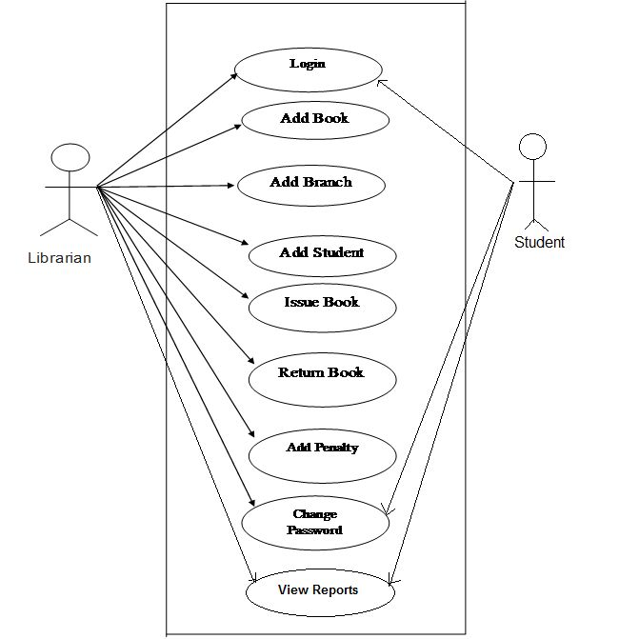

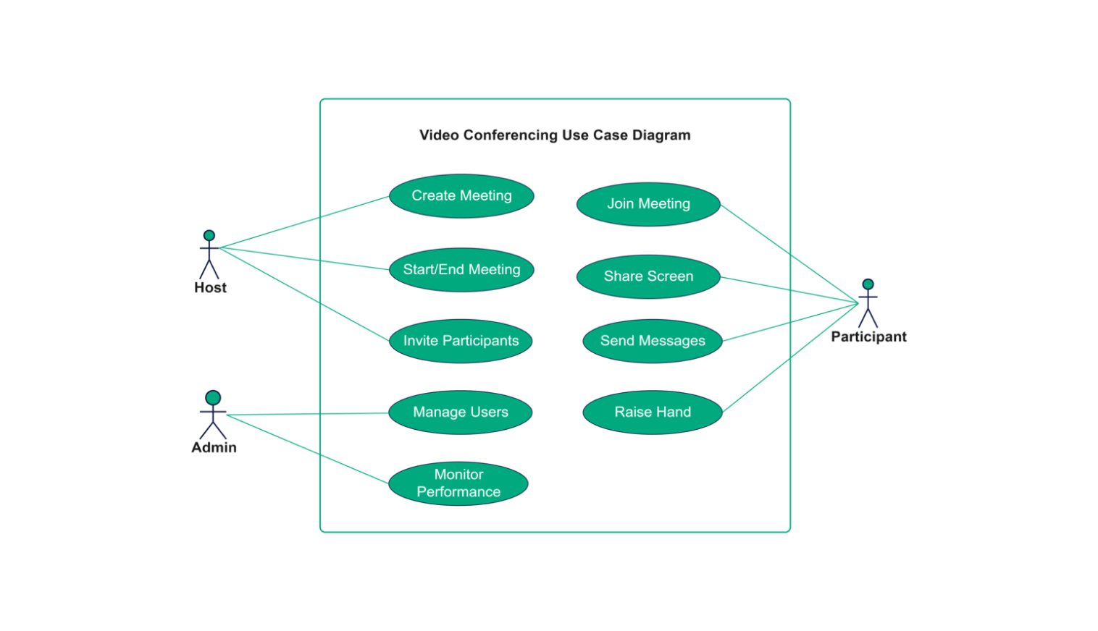

**SEQUENCE DIAGRAM**

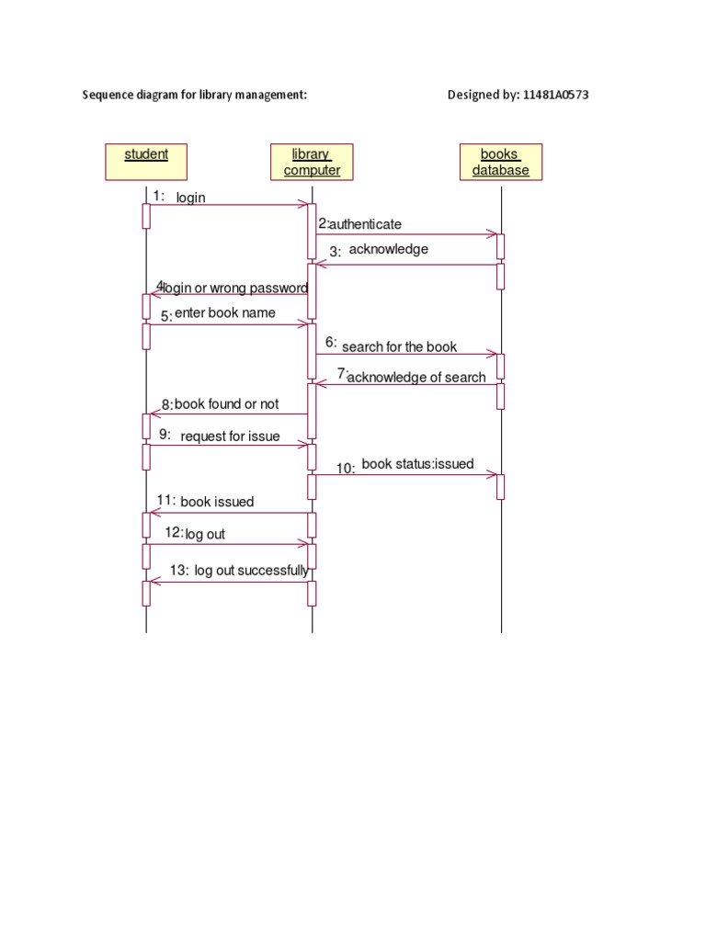

CLASS DIAGRAM

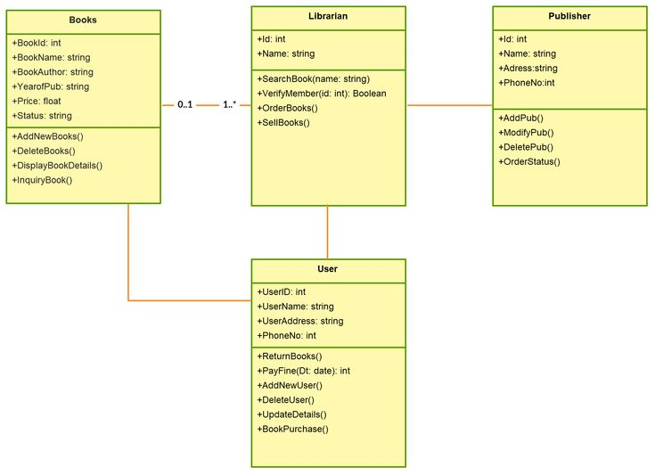

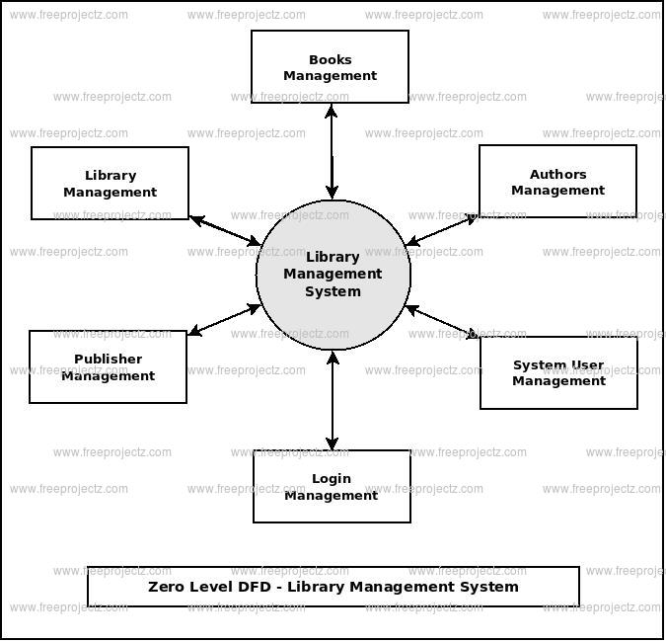

Data Centered Diagram

**GANTT CHART**

Task Start Date End Date Duration(Weeks)

1. Project Planning

& Requirements Gathering 01-Jan-2024 14-Jan-2024 2 weeks

2. Define system

requirements 01-Jan-2024 04-Jan-2024 1 week

3.Stakeholder meetings 05-Jan-2024 07-Jan-2024 1 week

Create project plan 08-Jan-2024 14-Jan-2024 1 week

4. System Design 15-Jan-2024 28-Jan-2024 2 weeks

5. Database design 15-Jan-2024 18-Jan-2024 1 week

6.UI/UX Design 19-Jan-2024 23-Jan-2024 1 week

7. System architecture design 24-Jan-2024 28-Jan-2024 1 week

8. Database Development 29-Jan-2024 11-Feb-2024 2 weeks

8. Create database schema 29-Jan-2024 01-Feb-2024 1 week

9.Develop CRUD operations 02-Feb-2024 05-Feb-2024 1 week

10. Integrate data storage

for books, users,

and transactions 06-Feb-2024 11-Feb-2024 1 week

**Actors**

1. **Library Administrator/Manager**: This person manages the overall functioning of the library system, including adding/removing books, managing user accounts, overseeing circulation, and ensuring that the system operates smoothly.
2. **Librarian**: The librarian assists users in searching for books, issuing/returning items, and providing general library services. They often help manage the inventory and maintain records of all the library's materials.
3. **Library Member/User**: These are the individuals who borrow books, search for resources, and use library services. They typically have an account where their borrowing history and fines (if applicable) are recorded.
4. **Cataloger**: This person is responsible for organizing and classifying the library's collection, adding new materials to the catalog, and ensuring that resources are properly categorized.
5. **System Administrator**: Responsible for maintaining the technical aspects of the LMS, such as ensuring the system is up and running, performing software updates, backing up data, and managing user access controls.

